
TWS Michael Schulthes

Damit man nur Gutes von Ihnen hört!

Winsener Str. 9, D 24568 Kattendorf, Tel. 04191 / 909990, FAX / 909991

Pass-by-Noise-Measurement System

Data Sheet

System for measurement and analysis of accelerated Bypass Noise according to ISO 362 and ECE 51

Applications:

- Quality control of vehicles
- Problem analysis of bypass noise
- Discrimination of tyre noise versus engine noise
- Analysis of gearbox noise

Technical properties
- 1 to 4 Measuring microphones (for instance left, right, exhaust system, engine compartment)
- Simultaneous measurement of both vehicle sides + the additional channels
- Measurement of Position, Speed, Rotational Speed and up to 6 additional values
- Analysis with 2 Spectra per m, 61 Spectra over the measuring lane
- Automatic averaging of the different bypasses
- ON-LINE calculation of average values and stray band
- ON-LINE calculation of WOT-Acceleration and other values necessary for the ECE 51 Tests
- True digital third-octave filters fulfilling ANSI CLASS-3
- FLOATING-POINT-Fourier analysis, 1600 lines
- Order analysis of engine- gearbox and tyre noise
- Compensation of Doppler-Effect enables precise Order Analysis
- Fully automatic procedures enable fast measurements without assistance

The measurement system is designed for measurement and analysis of bypass noise according to ISO 362 and ECE 51. It both uses digital third-octave-filters and FFT-Technique. During the pass-by the measurement data is displayed on the screen ON-LINE, furthermore the raw data of each bypass is transferred to the PC. This makes it possible to calculate Narrow-Band Spectra and Third-Octave-Spectra using identical sets of data.
When calculating narrow-band-spectra the error caused by the Doppler-effect can be compensated, so that even higher orders of engine noise or gearbox noise can be analysed precisely.
The system automatically recognises the direction of the bypass and automatically sorts the data. Bypasses with faulty input speed or faulty point of acceleration can be discarded automatically.
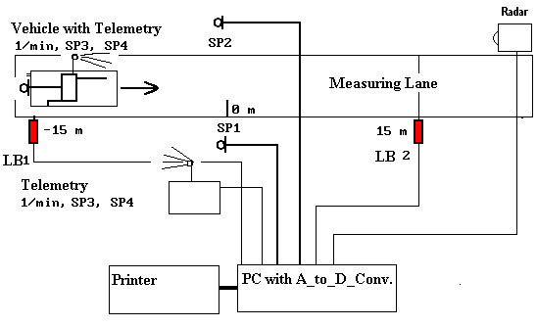

Hardware components:

- RPM meter with TTL output (recommended)
- RADAR Speed meter with 161 pulses per meter
(necessary)
- One or preferably 2 Light barriers with TTL Outputs
- At least one measuring microphone with preamp and cable, optionally wheatherproof
- Telemetric equipment to transfer the measurement signals from the vehicle to the PC
- A-to-D-card MICROSTAR DAP 3200/A212 or higher
- IBM compatible PC WINDOWS NT 4.0 or higher (WINDOWS XP recommended)
- Printer

Specifications:

Measuring Lane:
The measurement system takes into account the vehicle length to automatically adjust the length of the measurement lane. Therefore trucks or buses can be measured without readjusting anything!

Precision class:
When using measurement microphones of precision class one, all applicable requirements for precision sound level meters are fulfilled. The Front-End and the subsequent data processing fulfil precision class 0.

Frequency range of A-Level:
<20 HZ - >20 KHz, true RMS calculation using the A-weighted Input Signal.

Frequency range of third-octave-filters:
Centre frequencies of 25 HZ - 10 KHz , optionally Centre frequencies of 25 HZ - 20 KHz (LIN.).

Frequeny range of FFT:
Standard adjustment 0 to 13 KHz, spectral resolution
1600 Lines unweighted (LIN.).

Dynamic range:
Better than 70 dB.

RMS calculation:
True RMS Value for A-Level and third-octave-filters, time-constant "FAST".

Energetic averaging over 1 to maximum 5 Spectra per measurement point when calculating FFT, 50 % Overlap.

The averaging process when calculation the FFT avoids the normal reverberation effect spectral analysers normally have: spectra exactly refer to a certain vehicle position.

Doppler compensation:
Switchable, when enabled the spectra of the outdoor microphones are corrected that no Doppler effect remains. This allows for precise order analysis even of higher gearbox orders.

ON-LINE-checking of measurements
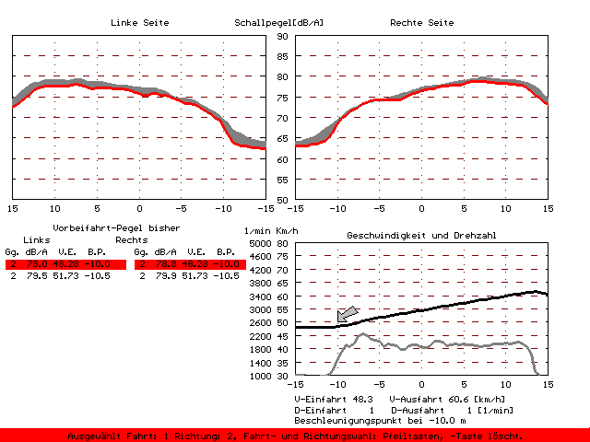
The system supports the user with a variety of ON-LINE-checks preventing invalid data to spoil the measurement.
Checked are input level, initial speed, final speed, acceleration point, initial RPM, final RPM, position of kickdown and wind speed.

Measurements failing to lie within the setpoints can be rejected automatically.

Furthermore all measurements are displayed together with their respective stray band. The user easily can highlight every single measurement in the stray-band after the measurement and decide whether or not to use it. Bad runs can be erased and additional measurements added until the desired number of bypasses is complete.

Data storage:
Third-octave spectra with additional information about RPM, Speed and extra information separately for each vehicle side.
Raw data for later narrow-band-analysis.
During the measurement the user can choose to store the raw data of each bypass, of the loudest, of the most representative or no raw data storage at all.

Analysis routines:

Normal curve-plotting:
Generates the reports.
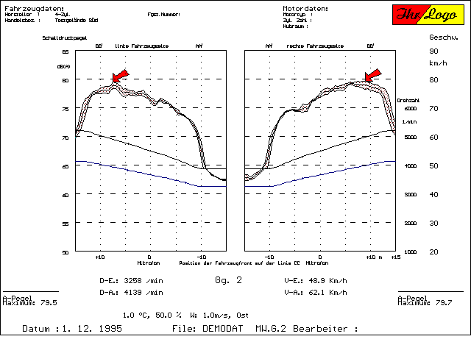
Example of Curve Plotting

Curve-plotting among others supports the following:
A-Level, any Octave or Third-Octave, Speed, Acceleration, RPM, B-, C-, or LIN- Level, versus Position. Stray Band, Initial Speed, final Speed, initial RPM, final RPM, .....
The final Speed and RPM calculations automatically check for the vehicle length! Measurements in different gears can be plotted automatically.

Order Analysis: calculates and plots any order of either Engine or Tyres. The orders can be chosen after the measurement, of course.

Channel Analysis: like Order analysis, but with fixed frequencies or frequency ranges.
Broad band level versus position: calculates LIN., A-, B- or C-Level and plots versus position, optionally with added low- or high- pass function, for instance A-Level, 0 - 1200 Hz band-limited.

SLOW: enables a "SLOW MOTION" Display of the Measurement with additional cursor information.

3D: for coloured 3D-Plots or coloured CAMPELL-Diagrams of Narrow-band-data versus position.
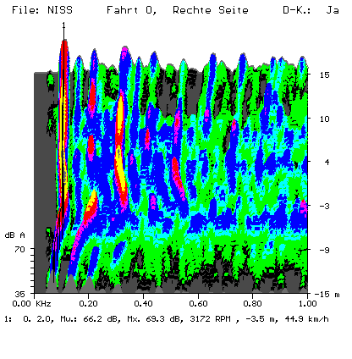
The completed 3-D-Plot can be analysed using:

3D/Order scan:
3D/Channel scan:

3D also can be used to reconstruct the RPM-axis using the Speed-axis on vehicles with manual gearboxes.
To achieve that the user enters the RPM-Order of a highlighted peak in the spectrum.
The software then reconstructs using this input the speed axes of all measurements in the same gear.
Even when analysing vehicles with automatic gearboxes, the speed axis can be reconstructed interactively.

General:

The system is very easy to use.
It can be modified according to the users demands.
The system can optionally be delivered with user interface in English, French or Italian language.
A Version for simulated bypass noise in the anechoic room is available upon request.

